**2. PL/SQL PROGRAMMING**

**Exercise 1: Control Structures**

**Scenario 1:** The bank wants to apply a discount to loan interest rates for customers above 60 years old.

**Question:** Write a PL/SQL block that loops through all customers, checks their age, and if they are above 60, apply a 1% discount to their current loan interest rates.

Inserting values:

Insert into Customers (CustomerID, Name, DOB, Balance, LastModified)

values (99, 'Test Senior', TO_DATE('1950-01-01','YYYY-MM-DD'), 1000, SYSDATE);

insert into Loans (LoanID, CustomerID, LoanAmount, InterestRate, StartDate, EndDate)

values (99, 99, 5000, 5, SYSDATE, ADD_MONTHS(SYSDATE, 60));

COMMIT;

**Code:**

SET SERVEROUTPUT ON;

BEGIN

FOR rec IN (

SELECT c.CustomerID, c.DOB, l.LoanID, l.InterestRate

FROM Customers c

JOIN Loans l ON c.CustomerID = l.CustomerID

) LOOP

IF MONTHS_BETWEEN(SYSDATE, rec.DOB)/12 > 60 THEN

UPDATE Loans

SET InterestRate = rec.InterestRate - 1

WHERE LoanID = rec.LoanID;

DBMS_OUTPUT.PUT_LINE('Discount applied to LoanID: ' || rec.LoanID);

END IF;

END LOOP;

END;

/

OUTPUT:



**Scenario 2:** A customer can be promoted to VIP status based on their balance.

**Question:** Write a PL/SQL block that iterates through all customers and sets a flag Is VIP to TRUE for those with a balance over $10,000.

ALTER TABLE Customers ADD IsVIP VARCHAR2(5);

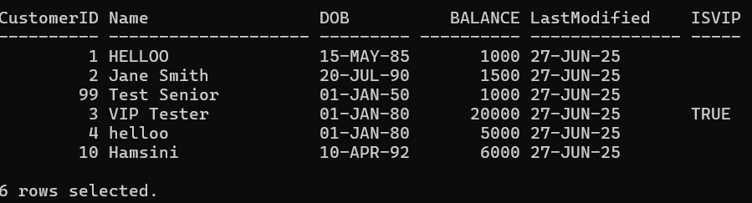

SET SERVEROUTPUT ON;

BEGIN

FOR rec IN (SELECT CustomerID, Balance FROM Customers) LOOP

IF rec.Balance > 10000 THEN

UPDATE Customers

SET IsVIP = 'TRUE'

WHERE CustomerID = rec.CustomerID;

DBMS_OUTPUT.PUT_LINE('Customer ' || rec.CustomerID || ' promoted to VIP.');

END IF;

END LOOP;

END;

/

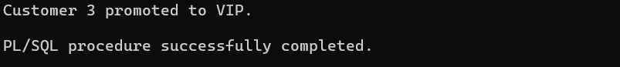

**Scenario 3:** The bank wants to send reminders to customers whose loans are due within the next 30 days.

**Question:** Write a PL/SQL block that fetches all loans due in the next 30 days and prints a reminder message for each customer.

BEGIN

FOR rec IN (

SELECT l.LoanID, c.Name, l.EndDate

FROM Loans l

JOIN Customers c ON l.CustomerID = c.CustomerID

WHERE l.EndDate BETWEEN SYSDATE AND SYSDATE + 30

) LOOP

DBMS_OUTPUT.PUT_LINE('Reminder: Loan ' || rec.LoanID ||' for customer ' || rec.Name ||' is due on ' || TO_CHAR(rec.EndDate, 'DD-MON-YYYY'));

END LOOP;

END;

/

OUTPUT:

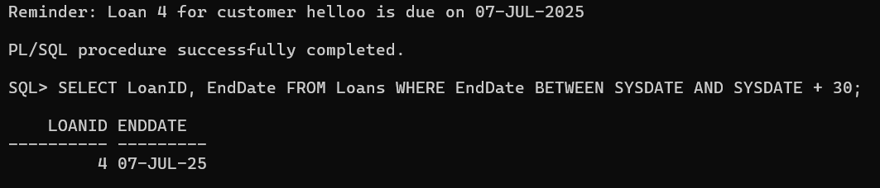

**Exercise 2: Error Handling**

**Scenario 1:** Handle exceptions during fund transfers between accounts.

**Question:** Write a stored procedure **SafeTransferFunds** that transfers funds between two accounts. Ensure that if any error occurs (e.g., insufficient funds), an appropriate error message is logged and the transaction is rolled back.

CREATE OR REPLACE PROCEDURE SafeTransferFunds(

p_from_account IN NUMBER, p_to_account IN NUMBER, p_amount IN NUMBER

) IS

v_balance NUMBER;

BEGIN

SELECT Balance INTO v_balance

FROM Accounts

WHERE AccountID = p_from_account;

IF v_balance < p_amount THEN

RAISE_APPLICATION_ERROR(-20001, 'Insufficient funds in source account');

END IF;

UPDATE Accounts

SET Balance = Balance - p_amount

WHERE AccountID = p_from_account;

UPDATE Accounts

SET Balance = Balance + p_amount

WHERE AccountID = p_to_account;

COMMIT;

DBMS_OUTPUT.PUT_LINE('Transfer of ' || p_amount || ' from Account 'p_from_account || ' to Account ' || p_to_account || ' completed.');

EXCEPTION

WHEN OTHERS THEN

ROLLBACK;

DBMS_OUTPUT.PUT_LINE('Error occurred: ' || SQLERRM);

END;

/

EXEC SafeTransferFunds(1, 2, 200);

OUTPUT:

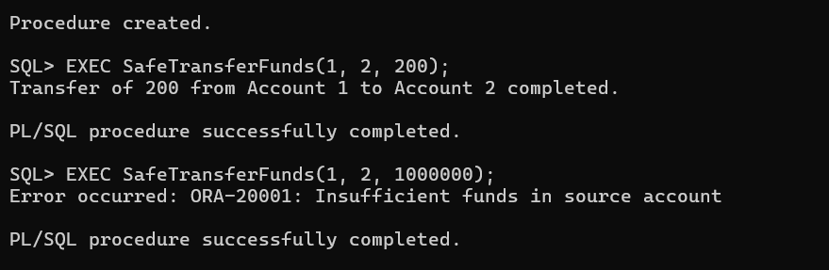

**Scenario 2:** Manage errors when updating employee salaries.

**Question:** Write a stored procedure **UpdateSalary** that increases the salary of an employee by a given percentage. If the employee ID does not exist, handle the exception and log an error message.

CREATE OR REPLACE PROCEDURE UpdateSalary(p_emp_id IN NUMBER,

p_percent IN NUMBER

) IS

v_rows NUMBER;

BEGIN

UPDATE Employees

SET Salary = Salary + (Salary * p_percent / 100)

WHERE EmployeeID = p_emp_id;

v_rows := SQL%ROWCOUNT;

IF v_rows = 0 THEN

RAISE_APPLICATION_ERROR(-20002, 'Employee with ID ' || p_emp_id || ' does not exist.');

ELSE

DBMS_OUTPUT.PUT_LINE('Salary updated successfully for Employee ID: ' || p_emp_id);

END IF;

EXCEPTION

WHEN OTHERS THEN

DBMS_OUTPUT.PUT_LINE('Error: ' || SQLERRM);

END;

/

EXEC UpdateSalary(1, 10);

OUTPUT:

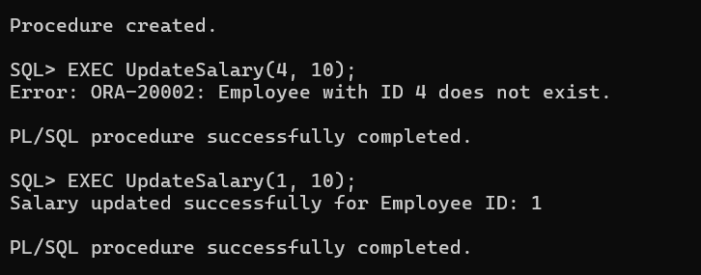

**Scenario 3:** Ensure data integrity when adding a new customer.

**Question:** Write a stored procedure **AddNewCustomer** that inserts a new customer into the Customers table. If a customer with the same ID already exists, handle the exception by logging an error and preventing the insertion.

CREATE OR REPLACE PROCEDURE AddNewCustomer (

p_customer_id IN NUMBER, p_name IN VARCHAR2, p_dob IN DATE,

p_balance IN NUMBER

) IS

BEGIN

INSERT INTO Customers (CustomerID, Name, DOB, Balance, LastModified)

VALUES (p_customer_id, p_name, p_dob, p_balance, SYSDATE);

DBMS_OUTPUT.PUT_LINE('Customer ' || p_name || ' added successfully.');

EXCEPTION

WHEN DUP_VAL_ON_INDEX THEN

DBMS_OUTPUT.PUT_LINE('Error: Customer with ID ' || p_customer_id || ' already exists.');

END;

/

EXEC AddNewCustomer(10, 'Hamsini', TO_DATE('1992-04-10','YYYY-MM-DD'), 6000);

OUTPUT:

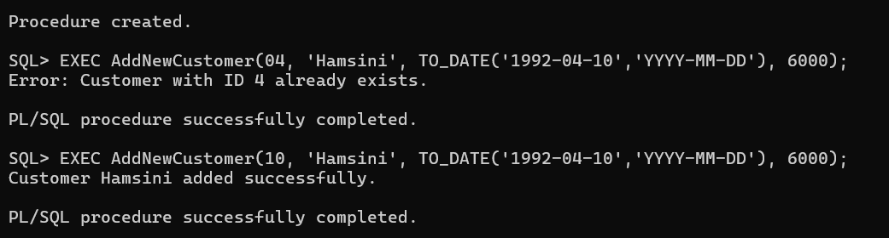

**Exercise 3: Stored Procedures**

**Scenario 1:** The bank needs to process monthly interest for all savings accounts.

**Question:** Write a stored procedure **ProcessMonthlyInterest** that calculates and updates the balance of all savings accounts by applying an interest rate of 1% to the current balance

CREATE OR REPLACE PROCEDURE ProcessMonthlyInterest IS

BEGIN

UPDATE Accounts

SET Balance = Balance + (Balance * 0.01)

WHERE AccountType = 'Savings';

DBMS_OUTPUT.PUT_LINE('Monthly interest applied to all savings accounts.');

EXCEPTION

END;

/

EXEC ProcessMonthlyInterest;

OUTPUT:

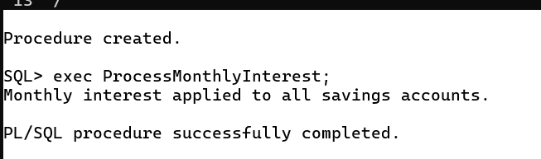

**Scenario 2:** The bank wants to implement a bonus scheme for employees based on their performance.

**Question:** Write a stored procedure **UpdateEmployeeBonus** that updates the salary of employees in a given department by adding a bonus percentage passed as a parameter.

CREATE OR REPLACE PROCEDURE UpdateEmployeeBonus (p_department IN VARCHAR2,

p_bonus_percent IN NUMBER

) IS

v_count NUMBER;

BEGIN

UPDATE Employees

SET Salary = Salary + (Salary * p_bonus_percent / 100)

WHERE Department = p_department;

v_count := SQL%ROWCOUNT;

IF v_count = 0 THEN

DBMS_OUTPUT.PUT_LINE('No employees found in department ' || p_department);

ELSE

DBMS_OUTPUT.PUT_LINE('Bonus applied to ' || v_count || ' employee(s) in department ' || p_department);

END IF;

EXCEPTION

WHEN OTHERS THEN

DBMS_OUTPUT.PUT_LINE('Error occurred: ' || SQLERRM);

END;

/

OUTPUT:

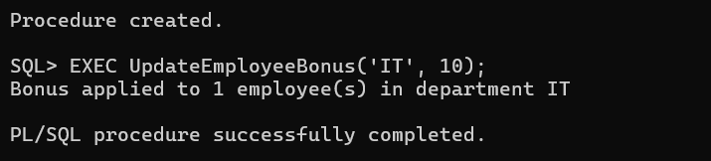

**Scenario 3:** Customers should be able to transfer funds between their accounts.

**Question:** Write a stored procedure **TransferFunds** that transfers a specified amount from one account to another, checking that the source account has sufficient balance before making the transfer.

CREATE OR REPLACE PROCEDURE TransferFunds (

p_from_account IN NUMBER,

p_to_account IN NUMBER,

p_amount IN NUMBER

) IS

v_balance NUMBER;

BEGIN

-- Check balance in source account

SELECT Balance INTO v_balance

FROM Accounts

WHERE AccountID = p_from_account;

IF v_balance < p_amount THEN

RAISE_APPLICATION_ERROR(-20001, 'Insufficient funds in source account');

END IF;

-- Debit source account

UPDATE Accounts

SET Balance = Balance - p_amount

WHERE AccountID = p_from_account;

-- Credit destination account

UPDATE Accounts

SET Balance = Balance + p_amount

WHERE AccountID = p_to_account;

COMMIT;

DBMS_OUTPUT.PUT_LINE('Transferred ' || p_amount ||

' from Account ' || p_from_account ||

' to Account ' || p_to_account);

EXCEPTION

WHEN OTHERS THEN

ROLLBACK;

DBMS_OUTPUT.PUT_LINE('Error: ' || SQLERRM);

END;

/

EXEC TransferFunds(1, 2, 150);

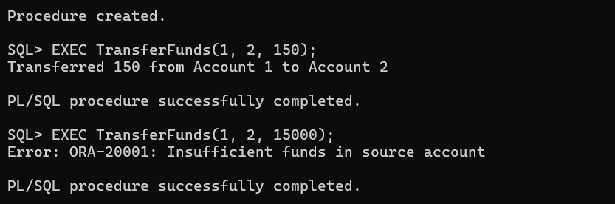

**Exercise 4: Functions**

**Scenario 1:** Calculate the age of customers for eligibility checks.

**Question:** Write a function CalculateAge that takes a customer's date of birth as input and returns their age in years.

CREATE OR REPLACE FUNCTION CalculateAge (

p_dob IN DATE

) RETURN NUMBER IS

v_age NUMBER;

BEGIN

v_age := FLOOR(MONTHS_BETWEEN(SYSDATE, p_dob) / 12);

RETURN v_age;

END;

/

OUTPUT: Function created.

DECLARE

v_age NUMBER;

BEGIN

v_age := CalculateAge(TO_DATE('1990-07-20','YYYY-MM-DD'));

DBMS_OUTPUT.PUT_LINE('Age is: ' || v_age);

END;

/

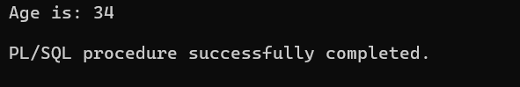

**Scenario 2:** The bank needs to compute the monthly installment for a loan.

**Question:** Write a function **CalculateMonthlyInstallment** that takes the loan amount, interest rate, and loan duration in years as input and returns the monthly installment amount.

CREATE OR REPLACE FUNCTION CalculateMonthlyInstallment (

p_loan_amount IN NUMBER,

p_annual_rate IN NUMBER,

p_years IN NUMBER

) RETURN NUMBER IS

v_monthly_rate NUMBER := p_annual_rate / 1200;

v_months NUMBER := p_years * 12;

v_emi NUMBER;

BEGIN

IF v_monthly_rate = 0 THEN

v_emi := p_loan_amount / v_months;

ELSE

v_emi := p_loan_amount * v_monthly_rate /

(1 - POWER(1 + v_monthly_rate, -v_months));

END IF;

RETURN ROUND(v_emi, 2);

END;

/



DECLARE

v_emi NUMBER;

BEGIN

v_emi := CalculateMonthlyInstallment(50000, 10, 2);

DBMS_OUTPUT.PUT_LINE('Monthly EMI: ' || v_emi);

END;

/

OUTPUT:

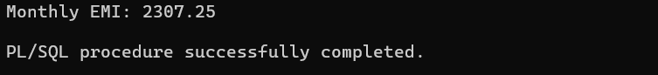

**Scenario 3:** Check if a customer has sufficient balance before making a transaction.

**Question:** Write a function **HasSufficientBalance** that takes an account ID and an amount as input and returns a boolean indicating whether the account has at least the specified amount.

SET SERVEROUTPUT ON;

DECLARE

v_result BOOLEAN;

BEGIN

v_result := HasSufficientBalance(1, 300);

IF v_result THEN

DBMS_OUTPUT.PUT_LINE('Sufficient balance available.');

ELSE

DBMS_OUTPUT.PUT_LINE('Insufficient balance.');

END IF;

END;

/

OUTPUT:

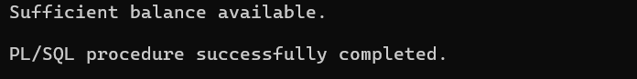

**Exercise 5: Triggers**

**Scenario 1:** Automatically update the last modified date when a customer's record is updated.

**Question:** Write a trigger **UpdateCustomerLastModified** that updates the LastModified column of the Customers table to the current date whenever a customer's record is updated.

DESC Customers; (lastModified exists)

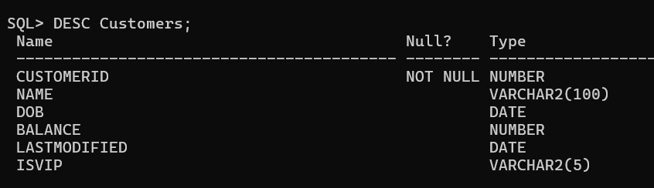

CREATE OR REPLACE TRIGGER UpdateCustomerLastModified

BEFORE UPDATE ON Customers

FOR EACH ROW

BEGIN

:NEW.LastModified := SYSDATE;

END;

/

OUTPUT: Trigger created.

SELECT CustomerID, Name, LastModified FROM Customers WHERE CustomerID = 1;

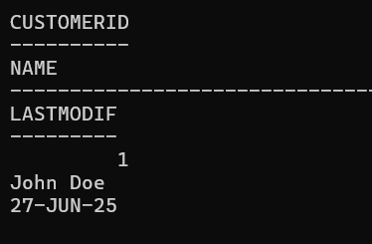

UPDATE Customers

SET Name = 'HELLOO'

WHERE CustomerID = 1;

COMMIT;

SELECT CustomerID, Name, LastModified FROM Customers WHERE CustomerID = 1;

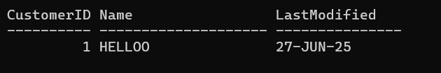

**Scenario 2:** Maintain an audit log for all transactions.

**Question:** Write a trigger **LogTransaction** that inserts a record into an AuditLog table whenever a transaction is inserted into the Transactions table.

CREATE TABLE AuditLog (

LogID NUMBER GENERATED ALWAYS AS IDENTITY PRIMARY KEY,

AccountID NUMBER, ActionDate DATE, Amount NUMBER, Type VARCHAR2(10)

);

CREATE OR REPLACE TRIGGER LogTransaction

AFTER INSERT ON Transactions

FOR EACH ROW

BEGIN

INSERT INTO AuditLog (AccountID, ActionDate, Amount, Type)

VALUES (:NEW.AccountID, SYSDATE, :NEW.Amount, :NEW.TransactionType);

END;

/

OUTPUT: Trigger Created.

INSERT INTO Transactions (TransactionID, AccountID, TransactionDate, Amount, TransactionType)

VALUES (10, 1, SYSDATE, 1000, 'Deposit');

COMMIT;

OUTPUT: 1 row created.

SELECT * FROM AuditLog ORDER BY LogID DESC;



**Scenario 3:** Enforce business rules on deposits and withdrawals.

**Question:** Write a trigger **CheckTransactionRules** that ensures withdrawals do not exceed the balance and deposits are positive before inserting a record into the Transactions table.

CREATE OR REPLACE TRIGGER CheckTransactionRules

BEFORE INSERT ON Transactions

FOR EACH ROW

DECLARE

v_balance NUMBER;

BEGIN

SELECT Balance INTO v_balance

FROM Accounts

WHERE AccountID = :NEW.AccountID;

IF :NEW.TransactionType = 'Withdrawal' THEN

IF :NEW.Amount > v_balance THEN

RAISE_APPLICATION_ERROR(-20001, 'Withdrawal exceeds available balance.');

ELSIF :NEW.Amount <= 0 THEN

RAISE_APPLICATION_ERROR(-20002, 'Withdrawal amount must be positive.');

END IF;

END IF;

IF :NEW.TransactionType = 'Deposit' THEN

IF :NEW.Amount <= 0 THEN

RAISE_APPLICATION_ERROR(-20003, 'Deposit amount must be positive.');

END IF;

END IF;

END;

/

OUTPUT: Trigger created.

INSERT INTO Transactions (TransactionID, AccountID, TransactionDate, Amount, TransactionType)

VALUES (201, 1, SYSDATE, 1000, 'Deposit');

COMMIT;

OUTPUT: 1 row created.

INSERT INTO Transactions (TransactionID, AccountID, TransactionDate, Amount, TransactionType)

VALUES (202, 1, SYSDATE, 999999, 'Withdrawal');

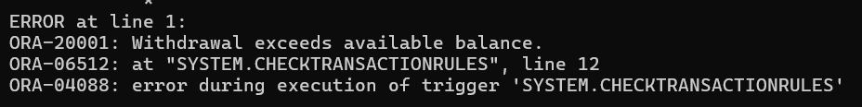

**Exercise 6: Cursors**

**Scenario 1:** Generate monthly statements for all customers.

**Question:** Write a PL/SQL block using an explicit cursor **GenerateMonthlyStatements** that retrieves all transactions for the current month and prints a statement for each customer.

DECLARE

CURSOR cur_monthly_statements IS

SELECT c.CustomerID, c.Name, a.AccountID, t.TransactionDate, t.Amount, t.TransactionType

FROM Customers c

JOIN Accounts a ON c.CustomerID = a.CustomerID

JOIN Transactions t ON a.AccountID = t.AccountID

WHERE TRUNC(t.TransactionDate, 'MM') = TRUNC(SYSDATE, 'MM')

ORDER BY c.CustomerID, t.TransactionDate;

v_customer_id Customers.CustomerID%TYPE;

v_name Customers.Name%TYPE;

v_account_id Accounts.AccountID%TYPE;

v_date Transactions.TransactionDate%TYPE;

v_amount Transactions.Amount%TYPE;

v_type Transactions.TransactionType%TYPE;

BEGIN

OPEN cur_monthly_statements;

LOOP

FETCH cur_monthly_statements INTO v_customer_id, v_name, v_account_id, v_date, v_amount, v_type;

EXIT WHEN cur_monthly_statements%NOTFOUND;

DBMS_OUTPUT.PUT_LINE(

'Customer: ' || v_name || ' (ID: ' || v_customer_id || ') | ' ||

'Account: ' || v_account_id || ' | ' ||

TO_CHAR(v_date, 'DD-MON-YYYY') || ' | ' ||

v_type || ': $' || v_amount

);

END LOOP;

CLOSE cur_monthly_statements;

END;

/

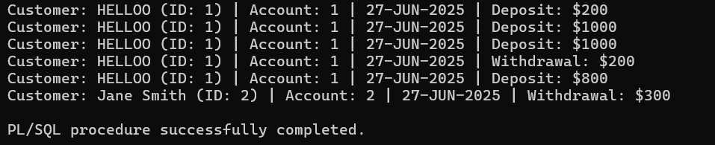

**Scenario 2:** Apply annual fee to all accounts.

**Question:** Write a PL/SQL block using an explicit cursor **ApplyAnnualFee** that deducts an annual maintenance fee from the balance of all accounts.

DECLARE

CURSOR cur_accounts IS

SELECT AccountID, Balance FROM Accounts;

v_account_id Accounts.AccountID%TYPE;

v_balance Accounts.Balance%TYPE;

v_fee CONSTANT NUMBER := 100;

BEGIN

OPEN cur_accounts;

LOOP

FETCH cur_accounts INTO v_account_id, v_balance;

EXIT WHEN cur_accounts%NOTFOUND;

UPDATE Accounts

SET Balance = Balance - v_fee

WHERE AccountID = v_account_id;

DBMS_OUTPUT.PUT_LINE('RS.' || v_fee || ' annual fee applied to Account ' || v_account_id);

END LOOP;

CLOSE cur_accounts;

COMMIT;

END;

/

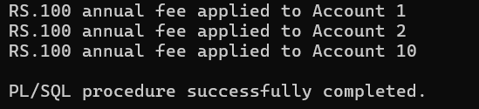

**Scenario 3:** Update the interest rate for all loans based on a new policy.

**Question:** Write a PL/SQL block using an explicit cursor **UpdateLoanInterestRates** that fetches all loans and updates their interest rates based on the new policy.

DECLARE

CURSOR cur_loans IS

SELECT LoanID, InterestRate FROM Loans;

v_loan_id Loans.LoanID%TYPE;

v_rate Loans.InterestRate%TYPE;

v_new_rate NUMBER;

BEGIN

OPEN cur_loans;

LOOP

FETCH cur_loans INTO v_loan_id, v_rate;

EXIT WHEN cur_loans%NOTFOUND;

IF v_rate < 6 THEN

v_new_rate := v_rate + 0.5;

ELSIF v_rate < 8 THEN

v_new_rate := v_rate + 0.25;

ELSE

v_new_rate := v_rate;

END IF;

IF v_new_rate != v_rate THEN

UPDATE Loans

SET InterestRate = v_new_rate

WHERE LoanID = v_loan_id;

DBMS_OUTPUT.PUT_LINE('Updated LoanID ' || v_loan_id ||': Interest rate changed from ' || v_rate ||' to ' || v_new_rate);

ELSE

DBMS_OUTPUT.PUT_LINE('LoanID ' || v_loan_id || ' already meets policy. No change.');

END IF;

END LOOP;

CLOSE cur_loans;

COMMIT;

END;

/

OUTPUT:

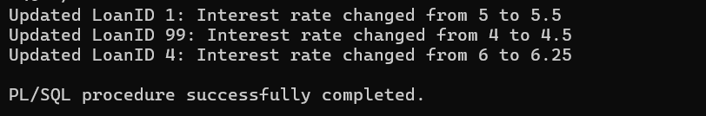

**Exercise 7: Packages**

**Scenario 1:** Group all customer-related procedures and functions into a package.

**Question:** Create a package **CustomerManagement** with procedures for adding a new customer, updating customer details, and a function to get customer balance.

CREATE OR REPLACE PACKAGE CustomerManagement IS

PROCEDURE AddCustomer(

p_id IN NUMBER,

p_name IN VARCHAR2,

p_dob IN DATE,

p_balance IN NUMBER

);

PROCEDURE UpdateCustomer(

p_id IN NUMBER,

p_name IN VARCHAR2

);

FUNCTION GetBalance(

p_id IN NUMBER

) RETURN NUMBER;

END CustomerManagement;

/

OUTPUT: Package created.

CREATE OR REPLACE PACKAGE BODY CustomerManagement IS

PROCEDURE AddCustomer(

p_id IN NUMBER,

p_name IN VARCHAR2,

p_dob IN DATE,

p_balance IN NUMBER

) IS

BEGIN

INSERT INTO Customers (CustomerID, Name, DOB, Balance, LastModified)

VALUES (p_id, p_name, p_dob, p_balance, SYSDATE);

DBMS_OUTPUT.PUT_LINE('Customer added: ' || p_name);

EXCEPTION

WHEN DUP_VAL_ON_INDEX THEN

DBMS_OUTPUT.PUT_LINE('Error: Customer ID already exists.');

WHEN OTHERS THEN

DBMS_OUTPUT.PUT_LINE('Unexpected Error: ' || SQLERRM);

END AddCustomer;

PROCEDURE UpdateCustomer(

p_id IN NUMBER,

p_name IN VARCHAR2

) IS

BEGIN

UPDATE Customers

SET Name = p_name

WHERE CustomerID = p_id;

IF SQL%ROWCOUNT = 0 THEN

DBMS_OUTPUT.PUT_LINE('No customer found with ID ' || p_id);

ELSE

DBMS_OUTPUT.PUT_LINE('Customer updated: ' || p_id);

END IF;

END UpdateCustomer;

FUNCTION GetBalance(

p_id IN NUMBER

) RETURN NUMBER IS

v_balance NUMBER;

BEGIN

SELECT Balance INTO v_balance FROM Customers WHERE CustomerID = p_id;

RETURN v_balance;

EXCEPTION

WHEN NO_DATA_FOUND THEN

DBMS_OUTPUT.PUT_LINE('Customer not found.');

RETURN NULL;

WHEN OTHERS THEN

DBMS_OUTPUT.PUT_LINE('Error: ' || SQLERRM);

RETURN NULL;

END GetBalance;

END CustomerManagement;

/

OUTPUT: Package body created.

EXEC CustomerManagement.AddCustomer(101, 'Srinivas', TO_DATE('1900-12-28', 'YYYY-MM-DD'), 10000);

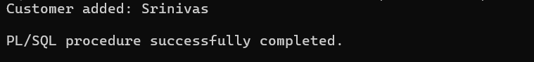

EXEC CustomerManagement.UpdateCustomer(101, 'Srinivas E.');

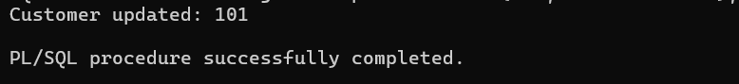

VARIABLE v_bal NUMBER;

BEGIN

:v_bal := CustomerManagement.GetBalance(101);

END;

/

PRINT v_bal;

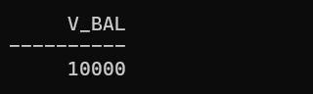

**Scenario 2:** Create a package to manage employee data.

**Question:** Write a package **EmployeeManagement** with procedures to hire new employees, update employee details, and a function to calculate annual salary.

CREATE OR REPLACE PACKAGE EmployeeManagement IS

PROCEDURE HireEmployee(

p_id IN NUMBER,

p_name IN VARCHAR2,

p_position IN VARCHAR2,

p_salary IN NUMBER,

p_dept IN VARCHAR2

);

PROCEDURE UpdateEmployeeDetails(

p_id IN NUMBER,

p_position IN VARCHAR2,

p_salary IN NUMBER

);

FUNCTION AnnualSalary(

p_id IN NUMBER

) RETURN NUMBER;

END EmployeeManagement;

/

OUTPUT: Package created.

CREATE OR REPLACE PACKAGE BODY EmployeeManagement IS

PROCEDURE HireEmployee(

p_id IN NUMBER,

p_name IN VARCHAR2,

p_position IN VARCHAR2,

p_salary IN NUMBER,

p_dept IN VARCHAR2

) IS

BEGIN

INSERT INTO Employees (EmployeeID, Name, Position, Salary, Department, HireDate)

VALUES (p_id, p_name, p_position, p_salary, p_dept, SYSDATE);

DBMS_OUTPUT.PUT_LINE('Employee ' || p_name || ' hired.');

EXCEPTION

WHEN DUP_VAL_ON_INDEX THEN

DBMS_OUTPUT.PUT_LINE('Error: Employee ID already exists.');

WHEN OTHERS THEN

DBMS_OUTPUT.PUT_LINE('Unexpected Error: ' || SQLERRM);

END HireEmployee;

PROCEDURE UpdateEmployeeDetails(

p_id IN NUMBER,

p_position IN VARCHAR2,

p_salary IN NUMBER

) IS

BEGIN

UPDATE Employees

SET Position = p_position,

Salary = p_salary

WHERE EmployeeID = p_id;

IF SQL%ROWCOUNT = 0 THEN

DBMS_OUTPUT.PUT_LINE('No employee found with ID ' || p_id);

ELSE

DBMS_OUTPUT.PUT_LINE('Employee ' || p_id || ' updated.');

END IF;

END UpdateEmployeeDetails;

FUNCTION AnnualSalary(

p_id IN NUMBER

) RETURN NUMBER IS

v_salary NUMBER;

BEGIN

SELECT Salary INTO v_salary FROM Employees WHERE EmployeeID = p_id;

RETURN v_salary * 12;

EXCEPTION

WHEN NO_DATA_FOUND THEN

DBMS_OUTPUT.PUT_LINE('Employee not found.');

RETURN NULL;

WHEN OTHERS THEN

DBMS_OUTPUT.PUT_LINE('Error: ' || SQLERRM);

RETURN NULL;

END AnnualSalary;

END EmployeeManagement;

/

OUTPUT: Package body created.

EXEC EmployeeManagement.HireEmployee(201, 'Harika', 'Analyst', 40000, 'Finance');



EXEC EmployeeManagement.UpdateEmployeeDetails(201, 'Senior Analyst', 50000);



VARIABLE v_salary NUMBER;

BEGIN

:v_salary := EmployeeManagement.AnnualSalary(201);

END;

/

PRINT v_salary;



SELECT * FROM Employees WHERE EmployeeID = 201;



**Scenario 3:** Group all account-related operations into a package.

**Question:** Create a package **AccountOperations** with procedures for opening a new account, closing an account, and a function to get the total balance of a customer across all accounts.

CREATE OR REPLACE PACKAGE AccountOperations IS

PROCEDURE OpenAccount(

p_account_id IN NUMBER,

p_customer_id IN NUMBER,

p_type IN VARCHAR2,

p_balance IN NUMBER

);

PROCEDURE CloseAccount(

p_account_id IN NUMBER

);

FUNCTION TotalBalance(

p_customer_id IN NUMBER

) RETURN NUMBER;

END AccountOperations;

/

OUTPUT: Package created.

CREATE OR REPLACE PACKAGE BODY AccountOperations IS

PROCEDURE OpenAccount(

p_account_id IN NUMBER,

p_customer_id IN NUMBER,

p_type IN VARCHAR2,

p_balance IN NUMBER

) IS

BEGIN

INSERT INTO Accounts (AccountID, CustomerID, AccountType, Balance, LastModified)

VALUES (p_account_id, p_customer_id, p_type, p_balance, SYSDATE);

DBMS_OUTPUT.PUT_LINE('Account ' || p_account_id || ' opened for Customer ' || p_customer_id);

EXCEPTION

WHEN DUP_VAL_ON_INDEX THEN

DBMS_OUTPUT.PUT_LINE('Error: Account ID already exists.');

WHEN OTHERS THEN

DBMS_OUTPUT.PUT_LINE('Unexpected Error: ' || SQLERRM);

END OpenAccount;

PROCEDURE CloseAccount(

p_account_id IN NUMBER

) IS

v_count NUMBER;

BEGIN

DELETE FROM Accounts

WHERE AccountID = p_account_id;

v_count := SQL%ROWCOUNT;

IF v_count = 0 THEN

DBMS_OUTPUT.PUT_LINE('No account found with ID ' || p_account_id);

ELSE

DBMS_OUTPUT.PUT_LINE('Account ' || p_account_id || ' closed.');

END IF;

END CloseAccount;

FUNCTION TotalBalance(

p_customer_id IN NUMBER

) RETURN NUMBER IS

v_total NUMBER;

BEGIN

SELECT NVL(SUM(Balance), 0)

INTO v_total

FROM Accounts

WHERE CustomerID = p_customer_id;

RETURN v_total;

EXCEPTION

WHEN OTHERS THEN

DBMS_OUTPUT.PUT_LINE('Error: ' || SQLERRM);

RETURN NULL;

END TotalBalance;

END AccountOperations;

/

OUTPUT: Package body created.

EXEC AccountOperations.OpenAccount(301, 1, 'Savings', 5000);

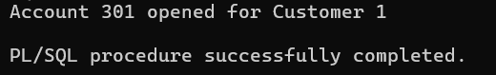

EXEC AccountOperations.CloseAccount(301);

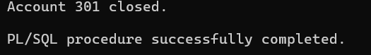

VARIABLE v_total_balance NUMBER;

BEGIN

:v_total_balance := AccountOperations.TotalBalance(1);

END;

/

PRINT v_total_balance;



SELECT * FROM Accounts WHERE CustomerID = 1;

